**Course & option:**

**DIT - SD**

**Project Title: Directie**

_______________________________________________________

**Organisation: Singapore Polytechnic**

_______________________________________________________

**Team Members**

1. Ng Hong Yao

2. Chia Kwee Cheng

3. Tay Wei Sern

4. Garick Chong

5. Chua Wei

**Supervisor: Ms Lin Zhao**

_______________________________________________________

**Technologies Used**

_______________________________________________________

* **Ionic 3 Framework**
* **Amazon Web Services (AWS)**
* **Firebase**

**Background**

_______________________________________________________

Navigation within an indoor environment has always been quite challenging. Needless to say, for the Visually Impaired, it can be even more challenging. Even though the Visually Impaired may have someone to guide them around, the guide may not always be available to do so.

This brings the need to come up with something that is reliable so that the Visually Impaired will be able to move around anywhere and anytime they want.

**Description**

_____________________________________________________

With our mobile application, Directie, it aims to assist the Visually Impaired in navigating within an indoor environment. It will utilise beacons to help detect the user’s location and the user will be able to go anywhere within the indoor environment that has beacons set up for it. Also, with Speech-To-Text and Text-To-Speech, the Visually Impaired can easily use the application.

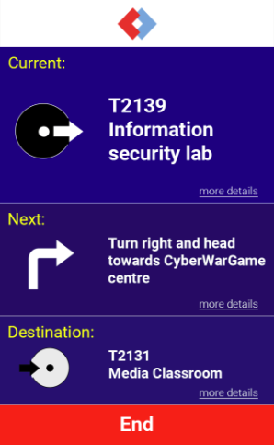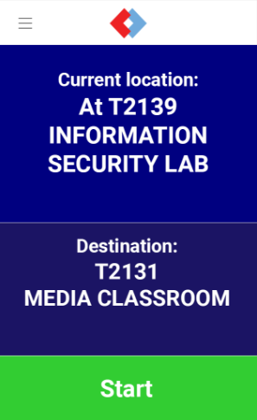

In addition, the web application for the administrators is developed to allow quick and easy implementation of the system as all resources being used can be managed in this admin portal.

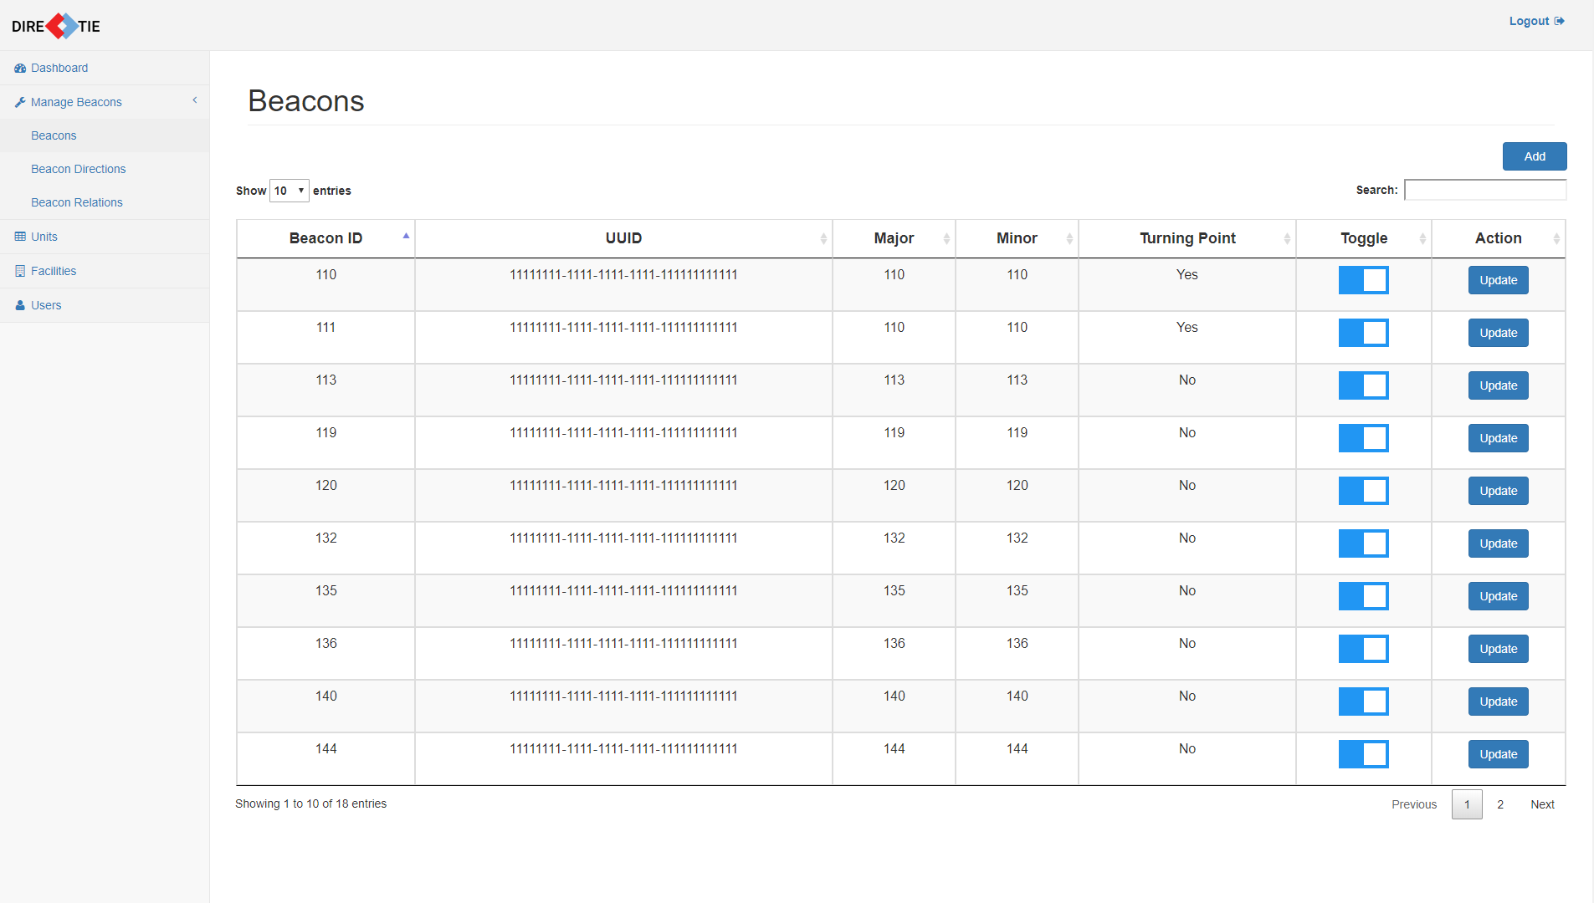

**Potential Opportunities**

**__________________________________________________**

Other than assisting the Visually Impaired(VI) in navigation, this application could be used to help the non-VI as well.

It can be implemented in places such as events whereby visitors can use the application and navigate around the event area easily. This could save the trouble of trying to find their way using maps or by signs placed at the location which can be confusing sometimes.